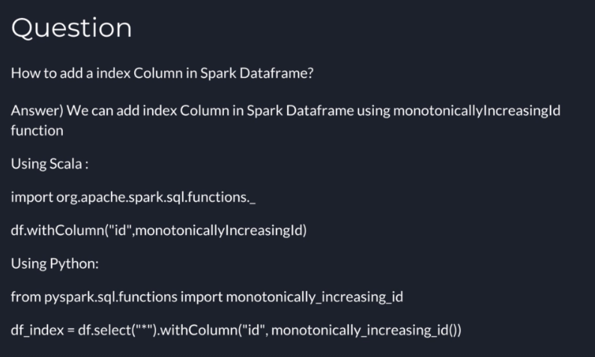



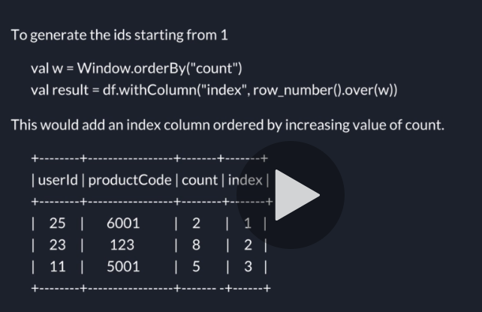

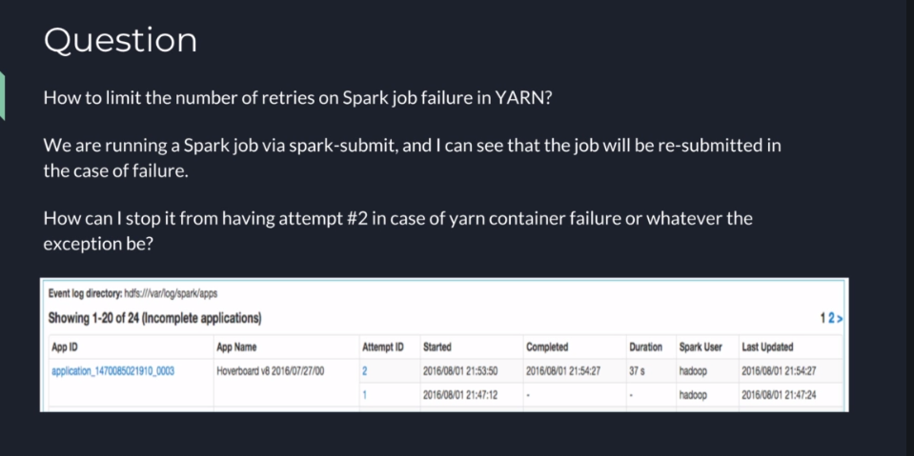

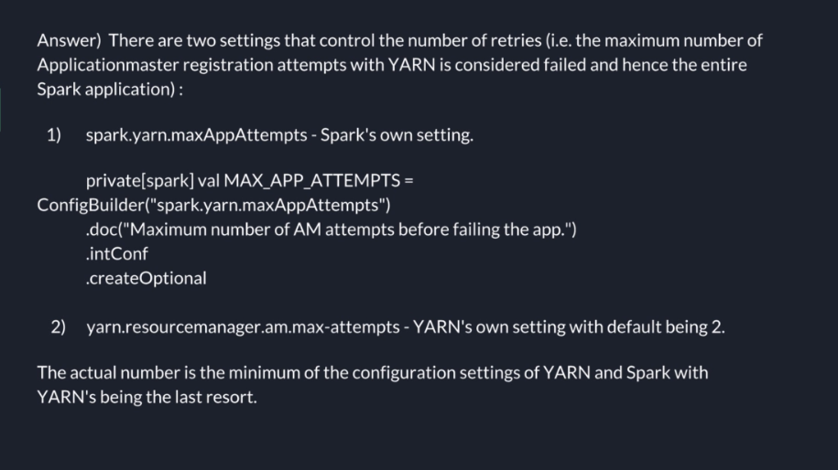

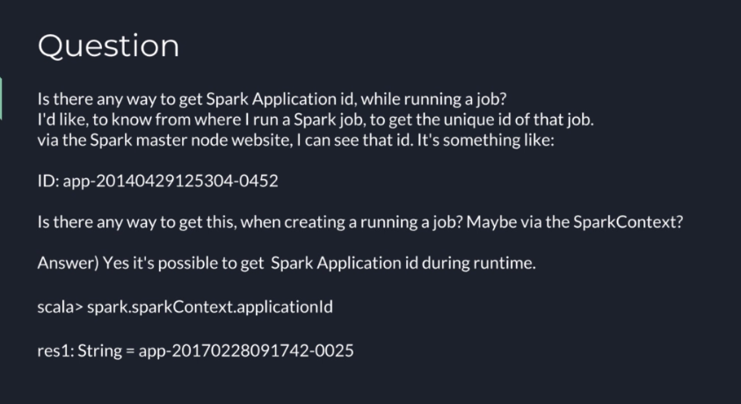

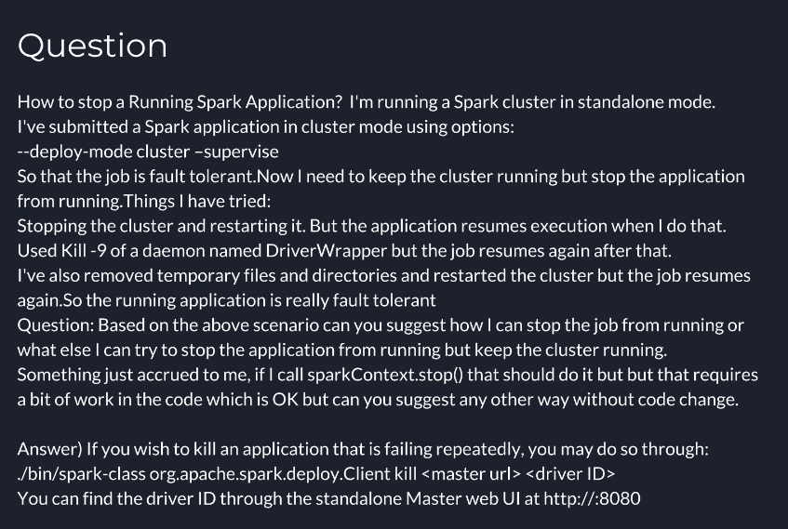

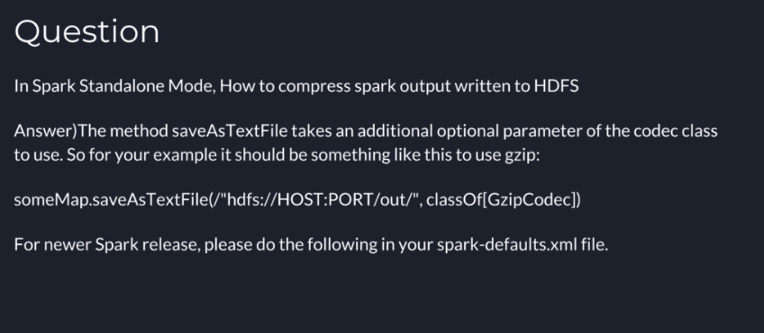

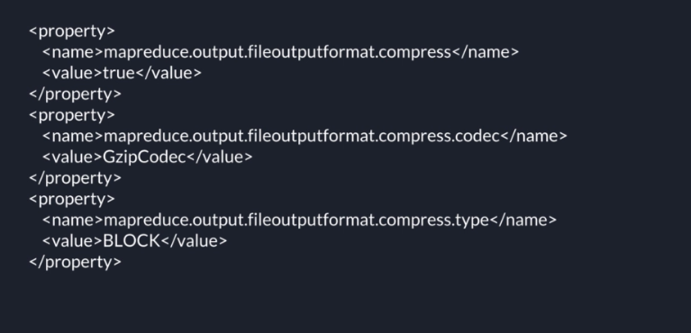

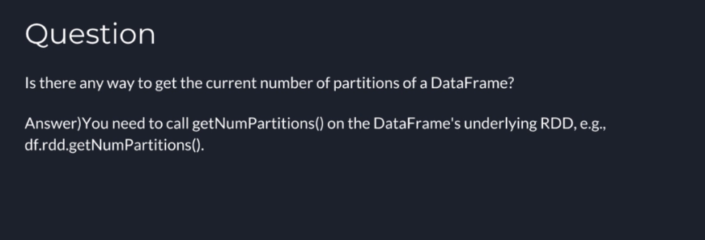

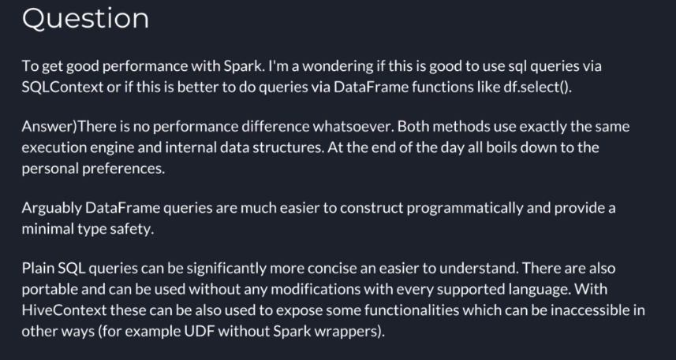

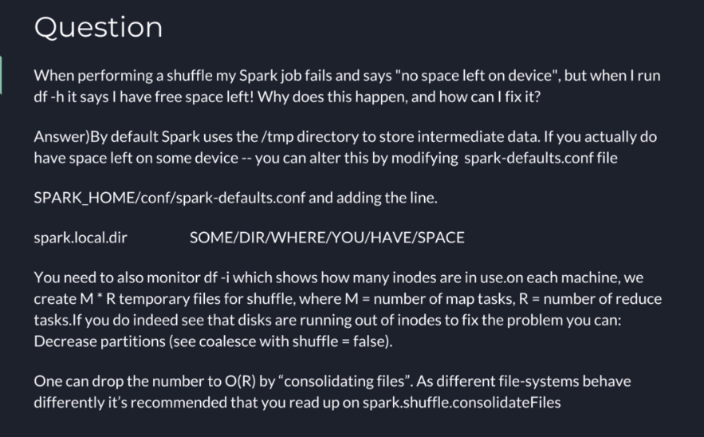

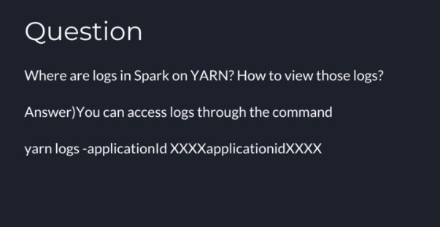

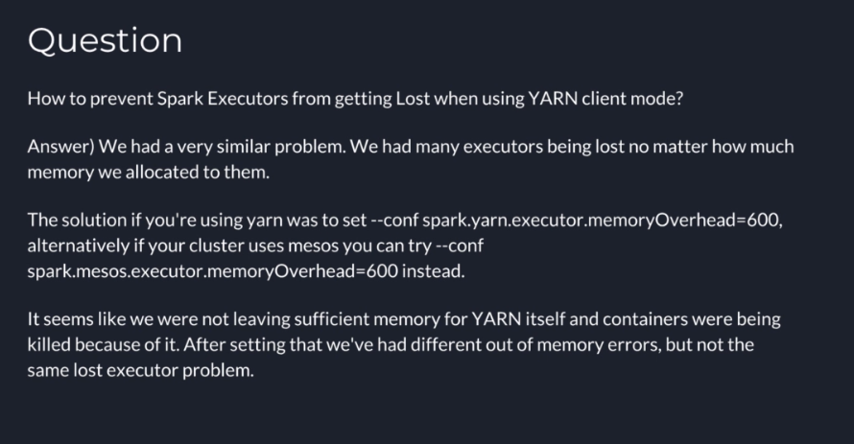

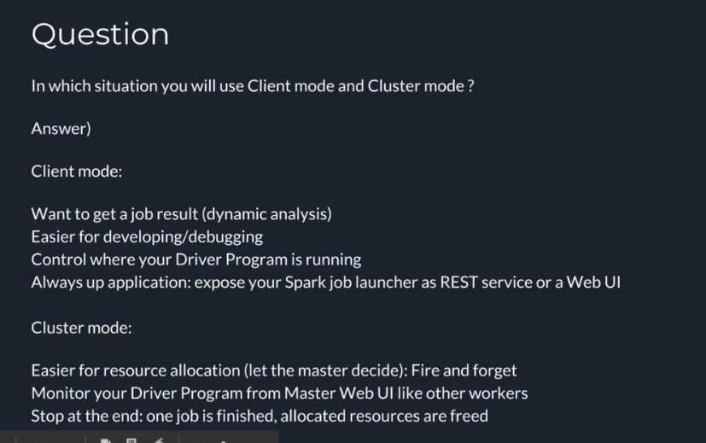

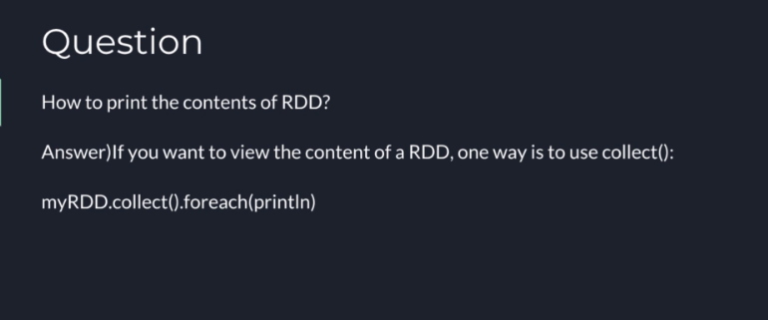

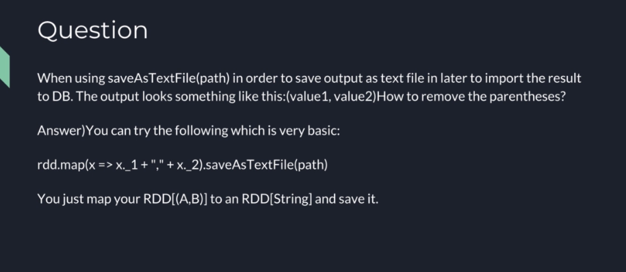

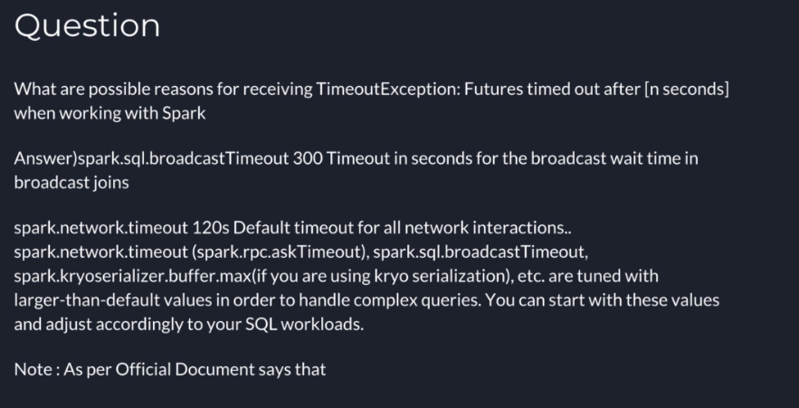

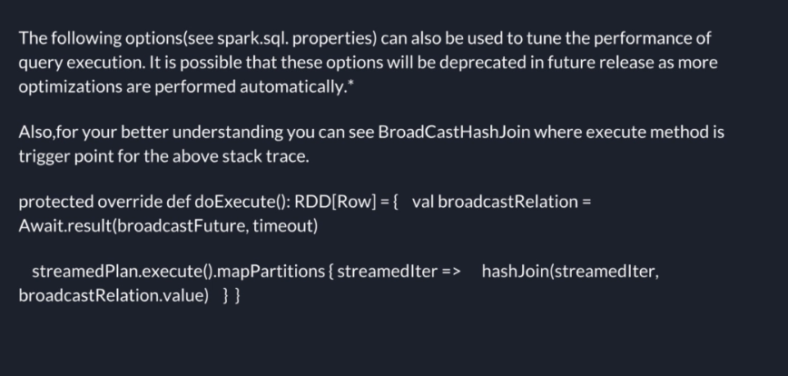

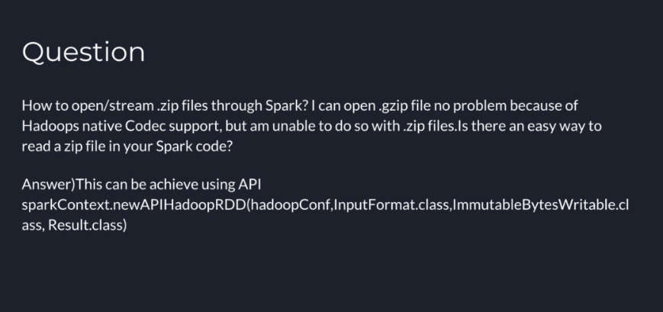

How to read multiline JSON in Apache Spark?

**How to read multiline JSON in Apache Spark?**

Answer)

Spark 2.2 introduced multiline option which can be used to load JSON (not JSONL) files:

1. spark.read
2. .option("multiline", true).option("mode", "PERMISSIVE")
3. .json("/path/to/user.json")

**Spark < 2.2**

Well, using JSONL formated data may be inconvenient but it I will argue that is not the issue with API but the format itself. JSON is simply not designed to be processed in parallel in distributed systems.

It provides no schema and without making some very specific assumptions about its formatting and shape it is almost impossible to correctly identify top level documents. Arguably this is the worst possible format to imagine to use in systems like Apache Spark. It is also quite tricky and typically impractical to write valid JSON in distributed systems.

That being said, if individual files are valid JSON documents (either single document or an array of documents) you can always try wholeTextFiles:

1. spark.read.json(sc.wholeTextFiles("/path/to/user.json").values())

How to replace NULL value in Spark Dataframe?

**How to replace NULL value in Spark Dataframe?**

**I'm trying to replace Null or invalid values present in a column with the most frequent value of that column.**

**For Example:-**

1. Name|Place
2. a |a1
3. a |a2
4. a |a2
5. |d1
6. b |a2
7. c |a2
8. c |
9. |
10. d |c1

Answer)

You can use .na.fill function (it is a function in org.apache.spark.sql.DataFrameNaFunctions).

Basically the function you need is: def fill(value: String, cols: Seq[String]): DataFrame

You can choose the columns, and you choose the value you want to replace the null or NaN.

In your case it will be something like:

1. val df2 = df.na.fill("a", Seq("Name"))
2. .na.fill("a2", Seq("Place"))

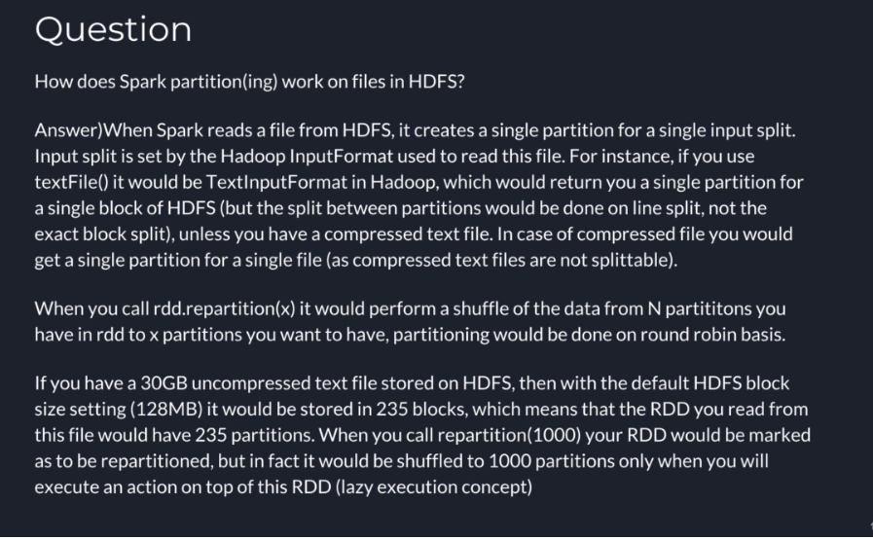

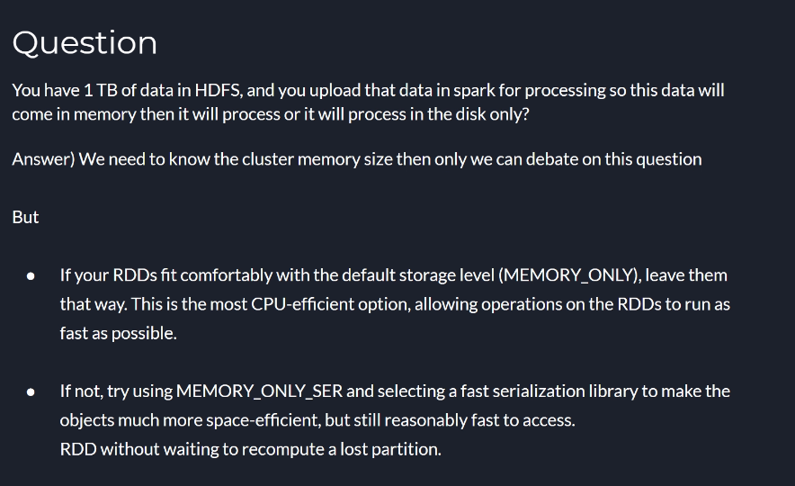

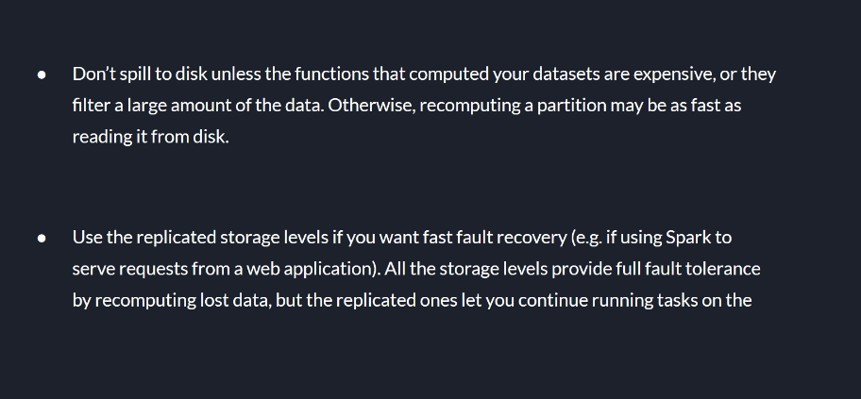

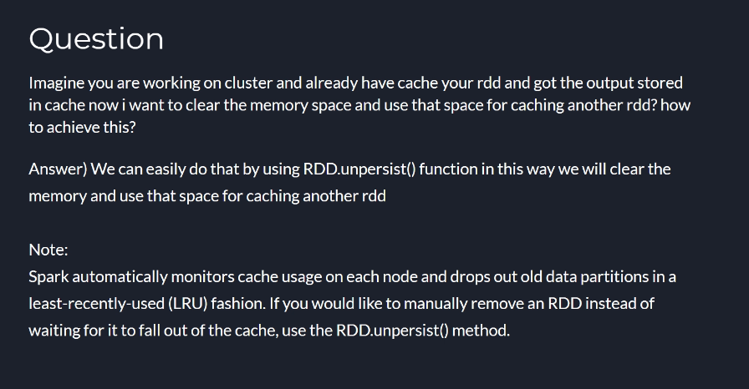

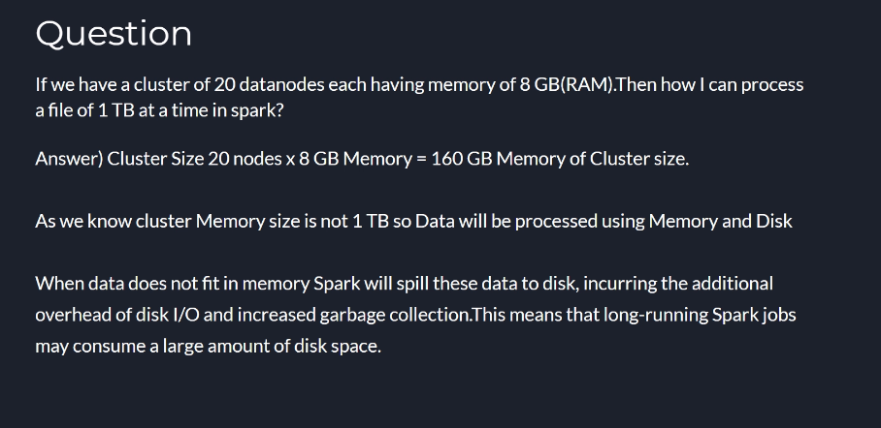

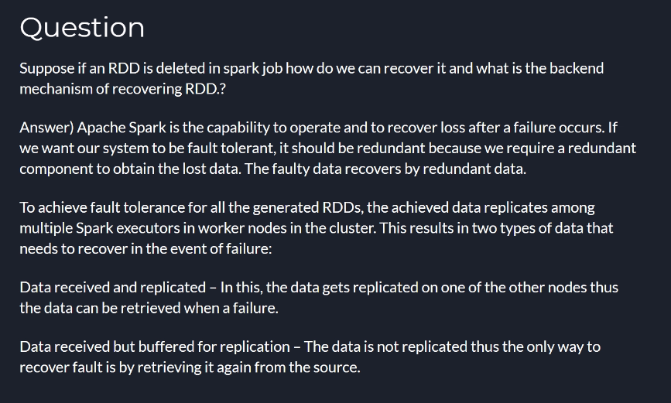

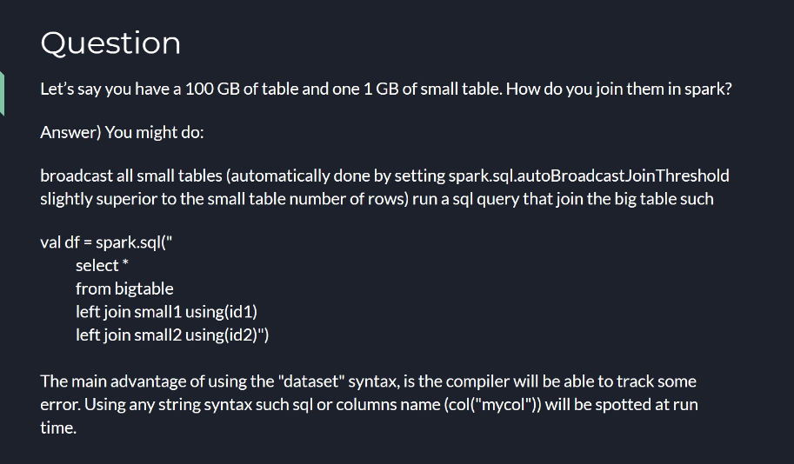

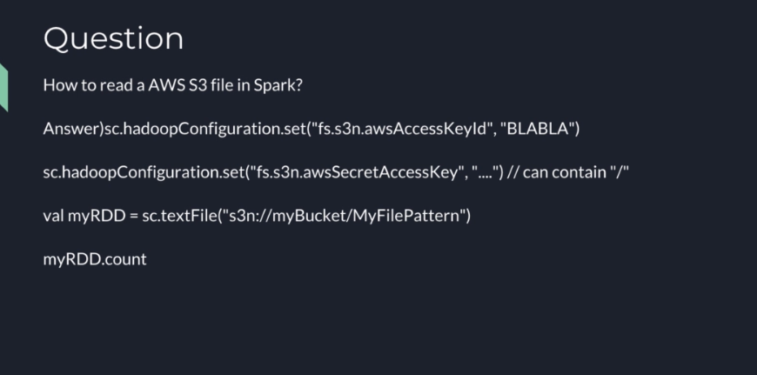

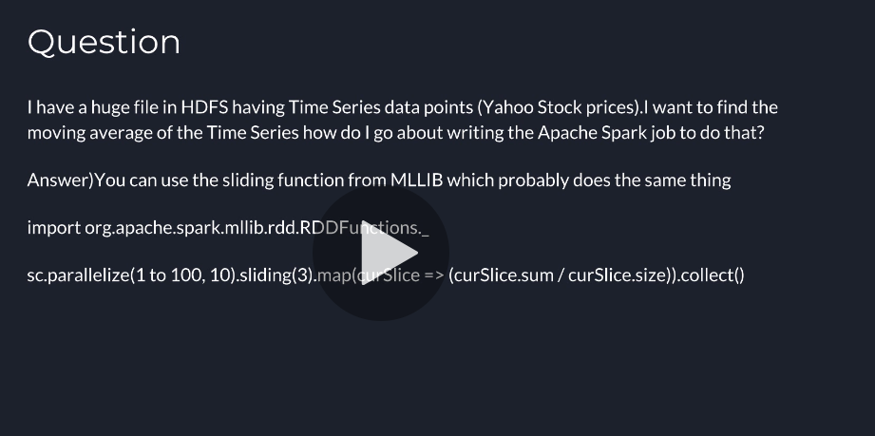

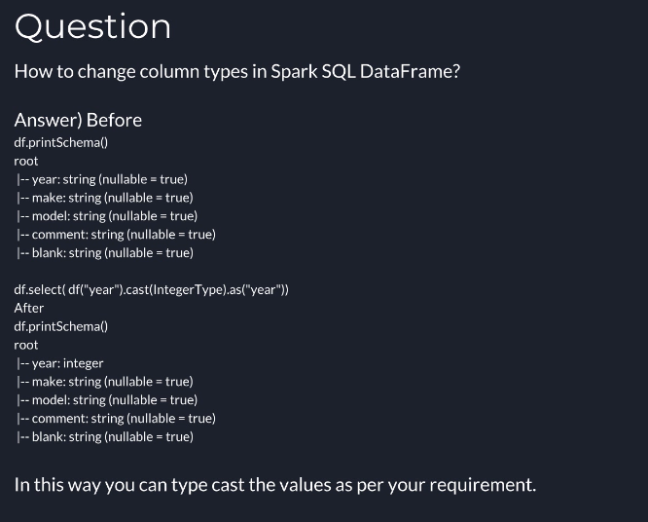

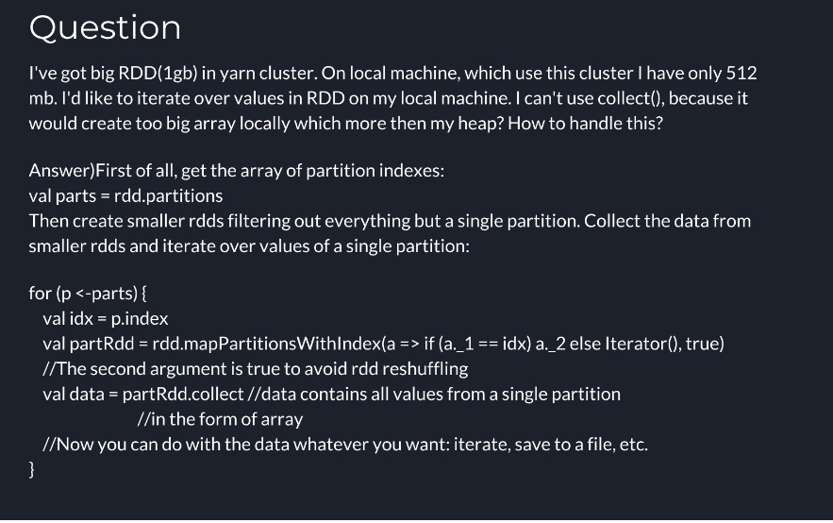

Is there any way for Spark to create primary keys?

**Is there any way for Spark to create primary keys?**

Answer)

**Scala**:

If all you need is unique numbers you can use zipWithUniqueId and recreate DataFrame. First some imports and dummy data:

1. import sqlContext.implicits._
2. import org.apache.spark.sql.Row
3. import org.apache.spark.sql.types.{StructType, StructField, LongType}
5. val df = sc.parallelize(Seq(
6. ("a", -1.0), ("b", -2.0), ("c", -3.0))).toDF("foo", "bar")

Extract schema for further usage:

1. val schema = df.schema

Add id field:

1. val rows = df.rdd.zipWithUniqueId.map{
2. case (r: Row, id: Long) => Row.fromSeq(id +: r.toSeq)}

Create DataFrame:

1. val dfWithPK = sqlContext.createDataFrame(
2. rows, StructType(StructField("id", LongType, false) +: schema.fields))

The same thing in **Python**:

1. from pyspark.sql import Row
2. from pyspark.sql.types import StructField, StructType, LongType
4. row = Row("foo", "bar")
5. row_with_index = Row(*["id"] + df.columns)
7. df = sc.parallelize([row("a", -1.0), row("b", -2.0), row("c", -3.0)]).toDF()
9. def make_row(columns):
10. def _make_row(row, uid):
11. row_dict = row.asDict()
12. return row_with_index(*[uid] + [row_dict.get(c) for c in columns])
13. return _make_row
15. f = make_row(df.columns)
17. df_with_pk = (df.rdd
18. .zipWithUniqueId()
19. .map(lambda x: f(*x))
20. .toDF(StructType([StructField("id", LongType(), False)] + df.schema.fields)))

If you prefer consecutive number your can replace zipWithUniqueId with zipWithIndex but it is a little bit more expensive.

**Directly with DataFrame API**:

*(universal Scala, Python, Java, R with pretty much the same syntax)*

Previously I've missed monotonicallyIncreasingId function which should work just fine as long as you don't require consecutive numbers:

1. import org.apache.spark.sql.functions.monotonicallyIncreasingId
3. df.withColumn("id", monotonicallyIncreasingId).show()
4. // +---+----+-----------+
5. // |foo| bar| id|
6. // +---+----+-----------+
7. // | a|-1.0|17179869184|
8. // | b|-2.0|42949672960|
9. // | c|-3.0|60129542144|
10. // +---+----+-----------+

While useful monotonicallyIncreasingId is non-deterministic. Not only ids may be different from execution to execution but without additional tricks cannot be used to identify rows when subsequent operations contain filters.

**Note**:

It is also possible to use rowNumber window function:

1. from pyspark.sql.window import Window
2. from pyspark.sql.functions import rowNumber
4. w = Window().orderBy()
5. df.withColumn("id", rowNumber().over(w)).show()

Unfortunately:

WARN Window: No Partition Defined for Window operation! Moving all data to a single partition, this can cause serious performance degradation.

So unless you have a natural way to partition your data and ensure uniqueness is not particularly useful at this moment.

How to add a constant column in a Spark DataFrame?

**How to add a constant column in a Spark DataFrame?**

Answer)

**Spark 2.2+**

Spark 2.2 introduces typedLit to support Seq, Map, and Tuples (SPARK-19254) and following calls should be supported (Scala):

1. import org.apache.spark.sql.functions.typedLit
3. df.withColumn("some_array", typedLit(Seq(1, 2, 3)))
4. df.withColumn("some_struct", typedLit(("foo", 1, .0.3)))
5. df.withColumn("some_map", typedLit(Map("key1" -> 1, "key2" -> 2)))

**Spark 1.3+** (lit), **1.4+** (array, struct), **2.0+** (map):

The second argument for DataFrame.withColumn should be a Column so you have to use a literal:

1. from pyspark.sql.functions import lit
3. df.withColumn('new_column', lit(10))

If you need complex columns you can build these using blocks like array:

1. from pyspark.sql.functions import array, create_map, struct
3. df.withColumn("some_array", array(lit(1), lit(2), lit(3)))
4. df.withColumn("some_struct", struct(lit("foo"), lit(1), lit(.3)))
5. df.withColumn("some_map", create_map(lit("key1"), lit(1), lit("key2"), lit(2)))

Exactly the same methods can be used in Scala.

1. import org.apache.spark.sql.functions.{array, lit, map, struct}
3. df.withColumn("new_column", lit(10))
4. df.withColumn("map", map(lit("key1"), lit(1), lit("key2"), lit(2)))

It is also possible, although slower, to use an UDF.

What does Stage Skipped mean in Apache Spark web UI?

**What does Stage Skipped mean in Apache Spark web UI?**

**From my Spark UI. What does it mean by skipped?**

Answer)

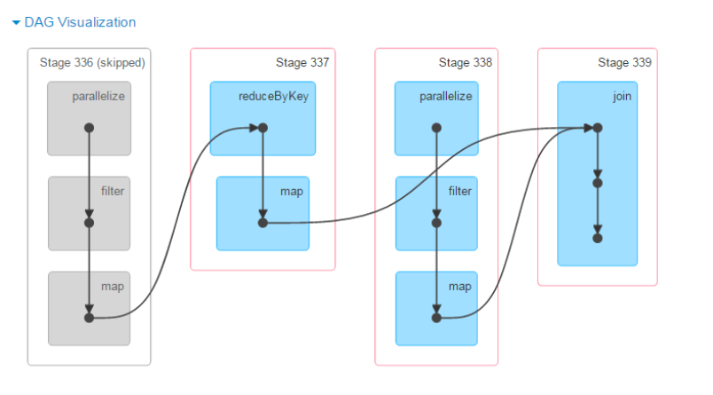

Typically it means that data has been fetched from cache and there was no need to re-execute given stage. It is consistent with your DAG which shows that the next stage requires shuffling (reduceByKey). Whenever there is shuffling involved Spark automatically caches generated data:

Shuffle also generates a large number of intermediate files on disk. As of Spark 1.3, these files are preserved until the corresponding RDDs are no longer used and are garbage collected. This is done so the shuffle files don’t need to be re-created if the lineage is re-computed.

How to concatenate columns in apache spark dataframe?

**How to concatenate columns in apache spark dataframe?**

Answer)

* In Python
  1. df = sqlContext.createDataFrame([("foo", 1), ("bar", 2)], ("k", "v"))
  2. df.registerTempTable("df")
  3. sqlContext.sql("SELECT CONCAT(k, ' ', v) FROM df")
* In Scala
  1. import sqlContext.implicits._
  3. val df = sc.parallelize(Seq(("foo", 1), ("bar", 2))).toDF("k", "v")
  4. df.registerTempTable("df")
  5. sqlContext.sql("SELECT CONCAT(k, ' ', v) FROM df")

Since Spark 1.5.0 you can use concat function with DataFrame API:

* In Python :
  1. from pyspark.sql.functions import concat, col, lit
  3. df.select(concat(col("k"), lit(" "), col("v")))
* In Scala :
  1. import org.apache.spark.sql.functions.{concat, lit}
  3. df.select(concat($"k", lit(" "), $"v"))

While processing CSV file resultant output is multiple file, wanted single file?

**While processing CSV file the resultant output is generating multiple CSV file, But our requirement to create single output file, How would you pursure to meet the requirement?**

Answer)Result is creating a folder with multiple files, because each partition is saved individually. If you need a single output file (still in a folder) you can re-partition (preferred if upstream data is large, but requires a shuffle):

df.repartition(1).write.format("com.databricks.spark.csv").option("header", "true").save("mydata.csv")

or coalesce:

df.coalesce(1).write.format("com.databricks.spark.csv").option("header", "true").save("mydata.csv")

Explain sortByKey() operation.

**Explain sortByKey() operation.**

Answer)sortByKey() is a transformation.It returns an RDD sorted by Key.Sorting can be done in (1) Ascending OR (2) Descending OR (3) custom sorting

1. scala> //Input
2. scala> val rdd = sc.parallelize(Seq(
3. | ("math", 55),
4. | ("math", 56),
5. | ("english", 57),
6. | ("english", 58),
7. | ("science", 59),
8. | ("science", 54)))
9. rdd: org.apache.spark.rdd.RDD[(String, Int)] = ParallelCollectionRDD[17] at parallelize at :21
11. scala> rdd.collect()
12. res8: Array[(String, Int)] = Array((math,55), (math,56), (english,57), (english,58), (science,59), (science,54))
14. scala> //Default Sorting : Ascending order
15. scala> val sorted1 = rdd.sortByKey()
16. sorted1: org.apache.spark.rdd.RDD[(String, Int)] = ShuffledRDD[20] at sortByKey at :23
18. scala> //Result
19. scala> sorted1.collect()
20. res9: Array[(String, Int)] = Array((english,57), (english,58), (math,55), (math,56), (science,59), (science,54))
22. scala> //Custom Sorting : Descending order (using implicit 'Ordering')
23. scala> {
24. | //Let us define an implicit sorting for the method sortByKey()
25. | //We have used '{' above to limit the scope of the implicit ordering
26. | implicit val sortIntegersByString = new Ordering[String] {
27. | override def compare(a: String, b: String) = {
28. | val result = a.compare(b)
29. | //We use -ve to sort the key in descending order
30. | -result
31. | }
32. | }
33. | val sorted2 = rdd.sortByKey()
34. |
35. | //Result
36. | sorted2.collect()
37. | }
38. res10: Array[(String, Int)] = Array((science,59), (science,54), (math,55), (math,56), (english,57), (english,58))
40. scala> //Default Sorting : Descending order (done using the 'ascending' flag argument)
41. scala> val sorted3 = rdd.sortByKey(false)
42. sorted3: org.apache.spark.rdd.RDD[(String, Int)] = ShuffledRDD[26] at sortByKey at :23
44. scala> //Result
45. scala> sorted3.collect()
46. res11: Array[(String, Int)] = Array((science,59), (science,54), (math, 55), (math,56), (english,57), (english,58))

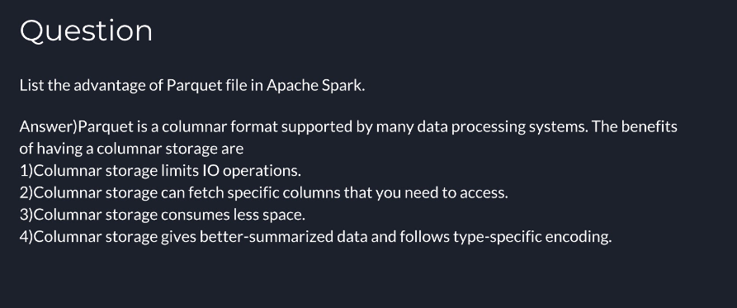

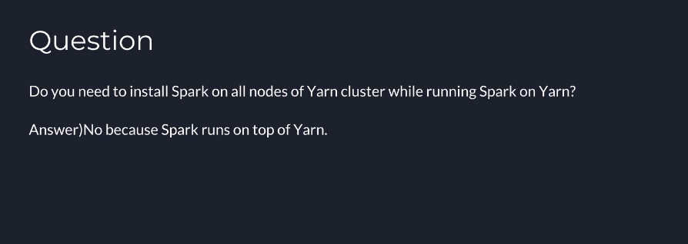

What is PageRank?

**What is PageRank?**

Answer)A unique feature and algorithm in graph, PageRank is the measure of each vertex in the graph. For instance, an edge from u to v represents endorsement of v’s importance by u. In simple terms, if a user at Instagram is followed massively, it will rank high on that platform.

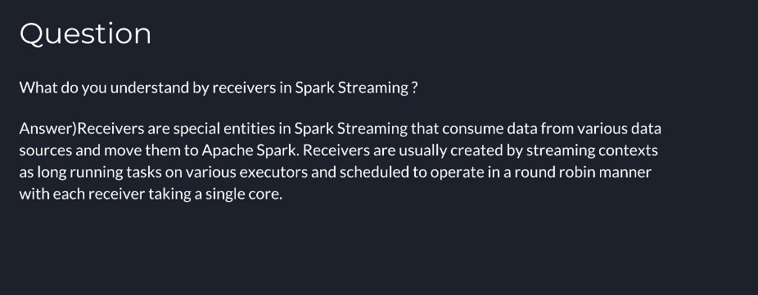

Name some source from where Spark streaming component can process real-time data

**Name some sources from where Spark streaming component can process real-time data.**

Answer) Apache Flume, Apache Kafka, Amazon Kinesis.

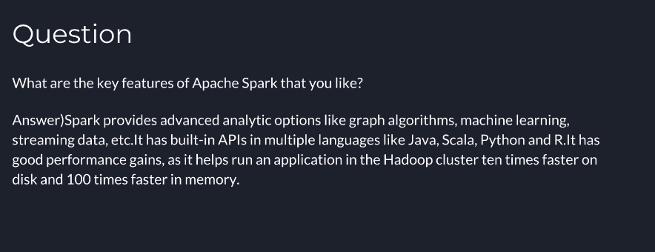

What are the various data sources available in SparkSQL?

**What are the various data sources available in SparkSQL?**

Answer)CSV file, Parquet file, JSON Datasets, Hive Table.

How to read multiple text files into a single RDD?

**How to read multiple text files into a single RDD?**

Answer) You can specify whole directories, use wildcards and even CSV of directories and wildcards. E.g.:

sc.textFile("/my/dir1,/my/paths/part-00[0-5]*,/another/dir,/a/specific/file")

Does SparkSQL support subquery?

**Does SparkSQL support subquery?**

Answer)Spark 2.0+

Spark SQL should support both correlated and uncorrelated subqueries. See SubquerySuite for details. Some examples include:

select * from l where exists (select * from r where l.a = r.c)

select * from l where not exists (select * from r where l.a = r.c)

select * from l where l.a in (select c from r)

select * from l where a not in (select c from r)

Unfortunately as for now (Spark 2.0) it is impossible to express the same logic using DataFrame DSL.

Spark < 2.0

Spark supports subqueries in the FROM clause (same as Hive <= 0.12).

SELECT col FROM (SELECT *  FROM t1 WHERE bar) t2

Have you ever encounter Spark java.lang.OutOfMemoryError? How to fix this issue?

**Have you ever encounter Spark java.lang.OutOfMemoryError? How to fix this issue?**

Answer)I have a few suggestions:

If your nodes are configured to have 6g maximum for Spark (and are leaving a little for other processes), then use 6g rather than 4g, spark.executor.memory=6g. Make sure you're using as much memory as possible by checking the UI (it will say how much mem you're using)

Try using more partitions, you should have 2 - 4 per CPU. IME increasing the number of partitions is often the easiest way to make a program more stable (and often faster). For huge amounts of data you may need way more than 4 per CPU, I've had to use 8000 partitions in some cases!

Decrease the fraction of memory reserved for caching, using spark.storage.memoryFraction. If you don't use cache() or persist in your code, this might as well be 0. It's default is 0.6, which means you only get 0.4 * 4g memory for your heap. IME reducing the mem frac often makes OOMs go away. UPDATE: From spark 1.6 apparently we will no longer need to play with these values, spark will determine them automatically.

Similar to above but shuffle memory fraction. If your job doesn't need much shuffle memory then set it to a lower value (this might cause your shuffles to spill to disk which can have catastrophic impact on speed). Sometimes when it's a shuffle operation that's OOMing you need to do the opposite i.e. set it to something large, like 0.8, or make sure you allow your shuffles to spill to disk (it's the default since 1.0.0).

Watch out for memory leaks, these are often caused by accidentally closing over objects you don't need in your lambdas. The way to diagnose is to look out for the "task serialized as XXX bytes" in the logs, if XXX is larger than a few k or more than an MB, you may have a memory leak.

Related to above; use broadcast variables if you really do need large objects.

If you are caching large RDDs and can sacrifice some access time consider serialising the RDD Or even caching them on disk (which sometimes isn't that bad if using SSDs).

How do I skip a header from CSV files in Spark?

**How do I skip a header from CSV files in Spark?**

Answer)

In Spark 2.0 a CSV reader is build into Spark, so you can easily load a CSV file as follows:

1. spark.read.option("header","true").csv("filePath")

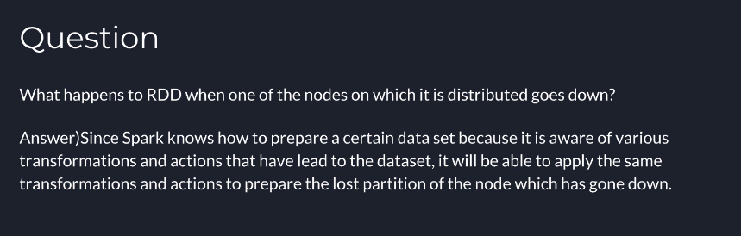

Certain data that we want to use again and again how to improve performance

**If there is certain data that we want to use again and again in different transformations what should improve the performance?**

Answer)RDD can be persisted or cached. There are various ways in which it can be persisted: in-memory, on disc etc. So, if there is a dataset that needs a good amount computing to arrive at, you should consider caching it. You can cache it to disc if preparing it again is far costlier than just reading from disc or it is very huge in size and would not fit in the RAM. You can cache it to memory if it can fit into the memory.

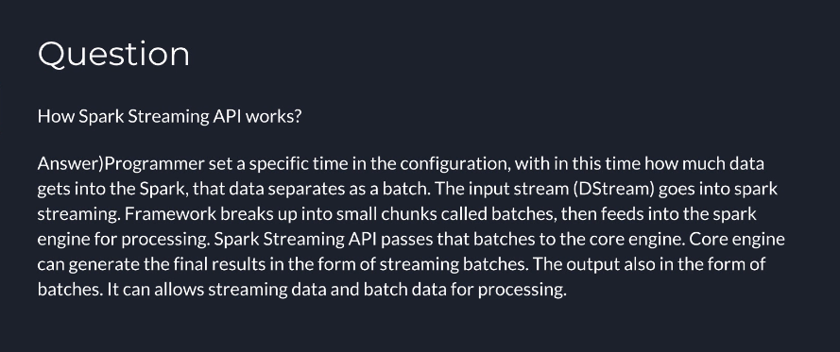

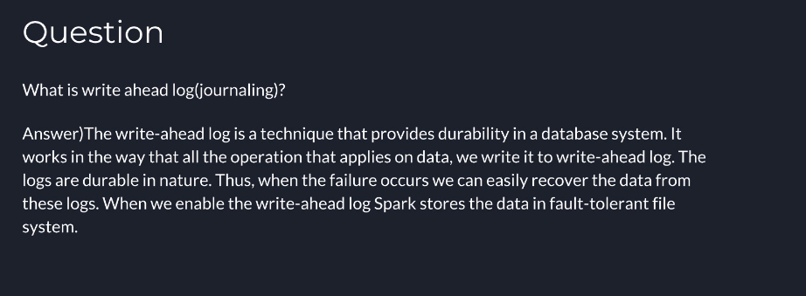

What are the advantages of DataFrame?

**What are the advantages of DataFrame?**

Answer)It makes large data set processing even easier. Data Frame also allows developers to impose a structure onto a distributed collection of data. As a result, it allows higher-level abstraction.

Data frame is both space and performance efficient.

It can deal with both structured and unstructured data formats, for example, Avro, CSV etc . And also storage systems like HDFS, HIVE tables, MySQL, etc.

The DataFrame API’s are available in various programming languages. For example Java, Scala, Python, and R.

It provides Hive compatibility. As a result, we can run unmodified Hive queries on existing Hive warehouse.

Catalyst tree transformation uses DataFrame in four phases: a) Analyze logical plan to solve references. b) Logical plan optimization c) Physical planning d) Code generation to compile part of the query to Java bytecode.

It can scale from kilobytes of data on the single laptop to petabytes of data on the large cluster.

What is Spark Driver?

**What is Spark Driver?**

Answer)Spark Driver is the program that runs on the master node of the machine and declares transformations and actions on data RDDs. In simple terms, a driver in Spark creates SparkContext, connected to a given Spark Master.

The driver also delivers the RDD graphs to Master, where the standalone cluster manager runs.

Fullscreen

What are benefits of Spark over MapReduce?

**What are benefits of Spark over MapReduce?**

Answer)Due to the availability of in-memory processing, Spark implements the processing around 10-100x faster than Hadoop MapReduce. MapReduce makes use of persistence storage for any of the data processing tasks.

Unlike Hadoop, Spark provides in-built libraries to perform multiple tasks form the same core like batch processing, Steaming, Machine learning, Interactive SQL queries. However, Hadoop only supports batch processing.

Hadoop is highly disk-dependent whereas Spark promotes caching and in-memory data storage.

Spark is capable of performing computations multiple times on the same dataset. This is called iterative computation while there is no iterative computing implemented by Hadoop.

What does a Spark Engine do?

What does a Spark Engine do?

Answer)Spark Engine is responsible for scheduling, distributing and monitoring the data application across the cluster.

Explain the difference between Spark SQL and Hive?

**Explain the difference between Spark SQL and Hive?**

Answer)Spark SQL is faster than Hive.

Any Hive query can easily be executed in Spark SQL but vice-versa is not true.

Spark SQL is a library whereas Hive is a framework.

It is not mandatory to create a metastore in Spark SQL but it is mandatory to create a Hive metastore.

Spark SQL automatically infers the schema whereas in Hive schema needs to be explicitly declared.

Which one will you choose for a project Hadoop MapReduce or Apache Spark?

**Which one will you choose for a project Hadoop MapReduce or Apache Spark?**

Answer)The answer to this question depends on the given project scenario - as it is known that Spark makes use of memory instead of network and disk I/O. However, Spark uses large amount of RAM and requires dedicated machine to produce effective results. So the decision to use Hadoop or Spark varies dynamically with the requirements of the project and budget of the organization

What is a DStream?

**What is a DStream?**

Answer)Discretized Stream is a sequence of Resilient Distributed Databases that represent a stream of data. DStreams can be created from various sources like Apache Kafka, HDFS, and Apache Flume. DStreams have two operations

Transformations that produce a new DStream.

Output operations that write data to an external system.

What is the significance of Sliding Window operation?

**What is the significance of Sliding Window operation?**

Answer)Sliding Window controls transmission of data packets between various computer networks. Spark Streaming library provides windowed computations where the transformations on RDDs are applied over a sliding window of data. Whenever the window slides, the RDDs that fall within the particular window are combined and operated upon to produce new RDDs of the windowed DStream.

How can you minimize data transfers when working with Spark?

**How can you minimize data transfers when working with Spark?**

Answer)Minimizing data transfers and avoiding shuffling helps write spark programs that run in a fast and reliable manner. The various ways in which data transfers can be minimized when working with Apache Spark are:

Using Broadcast Variable- Broadcast variable enhances the efficiency of joins between small and large RDDs.

Using Accumulators, Accumulators help update the values of variables in parallel while executing.

The most common way is to avoid operations ByKey, repartition or any other operations which trigger shuffles.

Is it possible to run Apache Spark on Apache Mesos?

**Is it possible to run Apache Spark on Apache Mesos?**

Answer)Yes, Apache Spark can be run on the hardware clusters managed by Mesos.

Can you use Spark to access and analyse data stored in Cassandra databases?

**Can you use Spark to access and analyse data stored in Cassandra databases?**

Answer)Yes, it is possible if you use Spark Cassandra Connector.

To perform Spark actions on table data, you first obtain a RDD object. To create the RDD object, create a Spark configuration object, which is then used to create a Spark context object.

1. import com.datastax.spark.connector._
2. val conf = new SparkConf(true)
3. .set("spark.cassandra.connection.host", "127.0.0.1")
4. val sc = new SparkContext("dse://127.0.0.1:7077", "test", conf)
5. val rdd = sc.cassandraTable("my_keyspace", "my_table")

To save data to the database in Scala applications, use the saveToCassandra method, passing in the keyspace, table, and mapping information.

1. val collection = sc.parallelize(Seq(("key3", 3), ("key4", 4)))
2. collection.saveToCassandra("my_keyspace", "my_table", SomeColumns("key", "value"))

To perform DSE Graph queries in a Scala application, you can cast a CassandraConnector session to acom.datastax.driver.dse.DseSession and then run graph statements using the executeGraphmethod.

1. val session = CassandraConnector(sc.getConf).withSessionDo(session => session.asInstanceOf[DseSession])
2. session.executeGraph(graph statement)

How can you define Spark Accumulators?

**How can you define Spark Accumulators?**

Answer)

Accumulators are variables that are "added" to through an associative and commutative "add" operation. They act as a container for accumulating partial values across multiple tasks (running on executors). They are designed to be used safely and efficiently in parallel and distributed Spark computations and are meant for distributed counters and sums (e.g. task metrics).  
You can create built-in accumulators for longs, doubles, or collections or register custom accumulators using the SparkContext.register methods. You can create accumulators with or without a name, but only named accumulators are displayed in web UI (under Stages tab for a given stage).

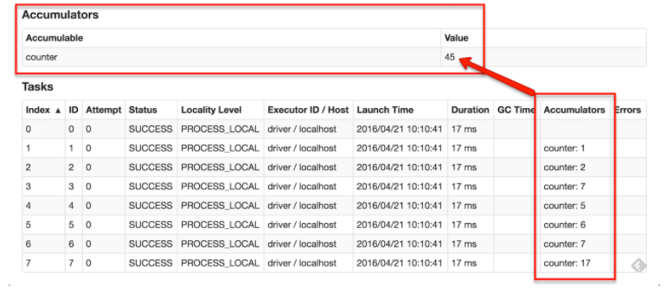

Which all cluster manager can be used with Spark?

Which all cluster manager can be used with Spark?

Answer)Apache Mesos, Hadoop YARN, Spark standalone

What is DAGSchedular and how it performs?

**What is DAGSchedular and how it performs?**

Answer)DAGScheduler is the scheduling layer of Apache Spark that implements stage-oriented scheduling, i.e. after an RDD action has been called it becomes a job that is then transformed into a set of stages that are submitted as TaskSets for execution.

Please define executors in detail?

**Please define executors in detail?**

Answer)Executors are distributed agents responsible for executing tasks. Executors provide in-memory storage for RDDs that are cached in Spark applications. When executors are started they register themselves with the driver and communicate directly to execute tasks.

Define Spark architecture?

**Define Spark architecture?**

Answer) Spark uses a master/worker architecture. There is a driver that talks to a single coordinator called master that manages workers in which executors run. The driver and the executors run in their own Java processes

What is checkpointing?

**What is checkpointing?**

Answer)Checkpointing is a process of truncating RDD lineage graph and saving it to a reliable distributed (HDFS) or local file system. RDD checkpointing that saves the actual intermediate RDD data to a reliable distributed file system.

What is the difference between groupByKey and use reduceByKey ?

**What is the difference between groupByKey and use reduceByKey ?**

Answer)Avoid groupByKey and use reduceByKey or combineByKey instead.

groupByKey shuffles all the data, which is slow.

reduceByKey shuffles only the results of sub-aggregations in each partition of the data.

Data is spread in all the nodes of cluster, how spark tries to process this data

**Data is spread in all the nodes of cluster, how spark tries to process this data?**

Answer)By default, Spark tries to read data into an RDD from the nodes that are close to it. Since Spark usually accesses distributed partitioned data, to optimize transformation operations it creates partitions to hold the data chunks

How would you control the number of partitions of a RDD?

**How would you control the number of partitions of a RDD?**

Answer)You can control the number of partitions of a RDD using repartition or coalesce operations.

How do you evaluate your spark application ?

**How do you evaluate your spark application for example i have access to a cluster (12 nodes where each node has 2 processors Intel(R) Xeon(R) CPU E5-2650 2.00GHz, where each processor has 8 cores), i want to know what are criteria that help me to tuning my application and to observe its performance.**

Answer)For tuning you application you need to know few things

1) You Need to Monitor your application whether your cluster is under utilized or not how much resources are used by your application which you have created

Monitoring can be done using various tools eg. Ganglia From Ganglia you can find CPU, Memory and Network Usage.

2) Based on Observation about CPU and Memory Usage you can get a better idea what kind of tuning is needed for your application

Form Spark point of you

In spark-defaults.conf

you can specify what kind of serialization is needed how much Driver Memory and Executor Memory needed by your application even you can change Garbage collection algorithm.

Below are few Example you can tune this parameter based on your requirements

spark.serializer                                        org.apache.spark.serializer.KryoSerializer

spark.driver.memory                               5g

spark.executor.memory                          3g

spark.executor.extraJavaOptions           -XX:MaxPermSize=2G -XX:+UseG1GC

spark.driver.extraJavaOptions               -XX:MaxPermSize=6G -XX:+UseG1GC

How do you disable Info Message when running Spark Application?

**How do you disable Info Message when running Spark Application?**

Answer)Under $SPARK_HOME/conf dir modify the log4j.properties file - change values INFO to ERROR

What is the Default level of parallelism in Spark?

**What is the Default level of parallelism in Spark?**

Answer)Default level of parallelism is the number of partitions when not specified explicitly by a user.

Which all kind of data processing supported by Spark?

**Which all kind of data processing supported by Spark?**

Answer)Spark offers three kinds of data processing using batch, interactive (Spark Shell), and stream processing with the unified API and data structures.

We understand Spark Streaming uses micro-batching. Does this increase latency?

**We understand Spark Streaming uses micro-batching. Does this increase latency?**

Answer)While Spark does use a micro-batch execution model, this does not have much impact on applications, because the batches can be as short as 0.5 seconds. In most applications of streaming big data, the analytics is done over a larger window (say 10 minutes), or the latency to get data in is higher (e.g. sensors collect readings every 10 seconds). Spark's model enables exactly-once semantics and consistency, meaning the system gives correct results despite slow nodes or failures.

Do I need Hadoop to run Spark?

**Do I need Hadoop to run Spark?**

Answer)No, but if you run on a cluster, you will need some form of shared file system (for example, NFS mounted at the same path on each node). If you have this type of filesystem, you can just deploy Spark in standalone mode.

Does my data need to fit in memory to use Spark?

**Does my data need to fit in memory to use Spark?**

Answer)No. Spark's operators spill data to disk if it does not fit in memory, allowing it to run well on any sized data. Likewise, cached datasets that do not fit in memory are either spilled to disk or recomputed on the fly when needed, as determined by the RDD's storage level.

How does Spark relate to Apache Hadoop?

**How does Spark relate to Apache Hadoop?**

Answer)Spark is a fast and general processing engine compatible with Hadoop data. It can run in Hadoop clusters through YARN or Spark's standalone mode, and it can process data in HDFS, HBase, Cassandra, Hive, and any Hadoop InputFormat. It is designed to perform both batch processing (similar to MapReduce) and new workloads like streaming, interactive queries, and machine learning.

